**Phillips College Week September 11th – 15th**

**Monday**

**“Let’s hear it for college spirit!”**

**Wear college gear or colors.**

MCj02381390000[1]

**Tuesday**

**“Boot scootin’ to college and career readiness”**

**Wear cowboy boots and cowboy gear.**

***(Sneak Peek for Book Fair Week!)***

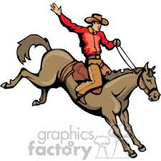

**Wednesday**

**“Dreaming of the perfect college and career for me!”**

**Wear Pajamas (must be in dress code).**

C:\Documents and Settings\henryk\Local Settings\Temporary Internet Files\Content.IE5\MW80JG1L\MC900044904[1].wmf



**Thursday**

**“Our Future is so Bright!”**

**Wear neon colors.**

**Friday**

**“Work Hard…Dream Big!”**

**Wear your Phillips shirt.**

